

*Transport for London*

**Dynamics 365 Technical Design Document**

Prepared for

***Transport for London***

Project

***Customer Service POC for TFL***

Prepared by

***Tarek Hesham Mostafa***

**Revision and Signoff Sheet**

**Change Record**

|  |  |  |  |
| --- | --- | --- | --- |
| Date | Author | Version | Change reference |
|  |  |  |  |

**Reviewers**

|  |  |  |  |
| --- | --- | --- | --- |
| Name | Version reviewed | Position | Date |
|  |  |  |  |

**Approvers**

|  |  |  |  |
| --- | --- | --- | --- |
| Name | Version reviewed | Position | Date |
|  |  |  |  |

**Table of Contents**

Table of Contents

Table of Contents 1

1 Overview 2

1.1 Objective 2

1.2 Audience 2

1.3 Acronyms & Abbreviations 2

1.4 References 2

1.5 Purpose and Overview 2

1.5.1 Requirement Overview 2

1.5.2 Solution Overview 2

2 Estimates (Hours) 3

3 Data MODEL (Customer Engagement) 4

3.1 <Entity> 4

3.1.1 Case 4

3.1.1.1 Form Scripts 4  
3.1.2.2 Model Driven App…………………………………………………………………………………………………………………………………..5

3.1.2.3 Plug-in Customization 5

3.1.2.4 Power Automte Flow 5

3.1.2.5 Business Process Flow………………………………………………………………………………………………5

3.1.2.6 Custom Actions 6

3.1.2.7 Business Rules 7

3.1.2.8 Web Resources 7

3.1.2.9 Advanced Customizations 7

3.1.2.10 Dashboards……………..………………………………………………………………………………………..8

3.1.2.11 Duplicate Detection Rule………………………………………………………………………………………..8

3.1.2.12 SLA…………………………………………………………………………………………………………………..8

4 Security design 8  
4.1.1 Business Units……………………………………………………………………………………………………………………………8  
4.1.2 Teams…………………………………………………………………………………………………………………………………….9  
4.1.3 Security Roles…………………………………………………………………………………………………………………………9

5 Unit Test 10

5.1.1 Test cases………………………………………………………………………………………………………………………………………….12







# Overview

## Objective

This document provides a comprehensive and detailed Low Level Design of the system, using number of different technical components to depict different features of the system







## Purpose and Overview

This document specifies technical details regarding the components involved in a MS implementation. It serves as a blueprint to the programmers to follow, provides guidance to the software developers, and discusses customizing certain components on top of Dynamics 365. This document is designed to be used in conjunction with functional design document.

## Requirement Overview

*Design Customer Service Module serve multiple centres*

## Solution Overview

## Using OOB Customer Service module with some additional customizations meet requirements



## 



# Estimates (Hours)

*[Description: The Estimates to be provided by the Developers.]*

|  |  |  |  |  |  |  |
| --- | --- | --- | --- | --- | --- | --- |
| **Design** | **Development** | **TQA /PMX review** | **Test/QA** | **Help Text/ Documentation** | **Deployment** | **Total** |
| 8h | 16h |  | 16h | 4h |  | 48h |























































































































# Data MODEL (Customer Engagement)

### <Entity>

### Case

### Form Events

This section describes actions to be taken on a specific event using client side programming model.

| Entity | Case | |
| --- | --- | --- |
| Attribute | Is Manager? (tfl_ismanager) |
| Trigger Point | On Load Form |
| Description | On Load case form we check who has logged in if the manager logged in, he will be able to see a button called “Follow-Up” else no one else can see it |
| Action | Change field to Yes and show button with some other conditions like if the case is confidential or he can’t resolve case |

### Follow-Up

### Form Event

This section describes actions to be taken on a specific event using client-side programming model.

| Entity | Follow-Up | |
| --- | --- | --- |
| Attribute | Case(tfl_case), Customer(tfl_customer) |
| Trigger Point | Open Case Details Tab/ Open Customer Details Tab |
| Description | On open case details tab we got main form of case with all details, On open customer details tab we got all details of customer |

### 

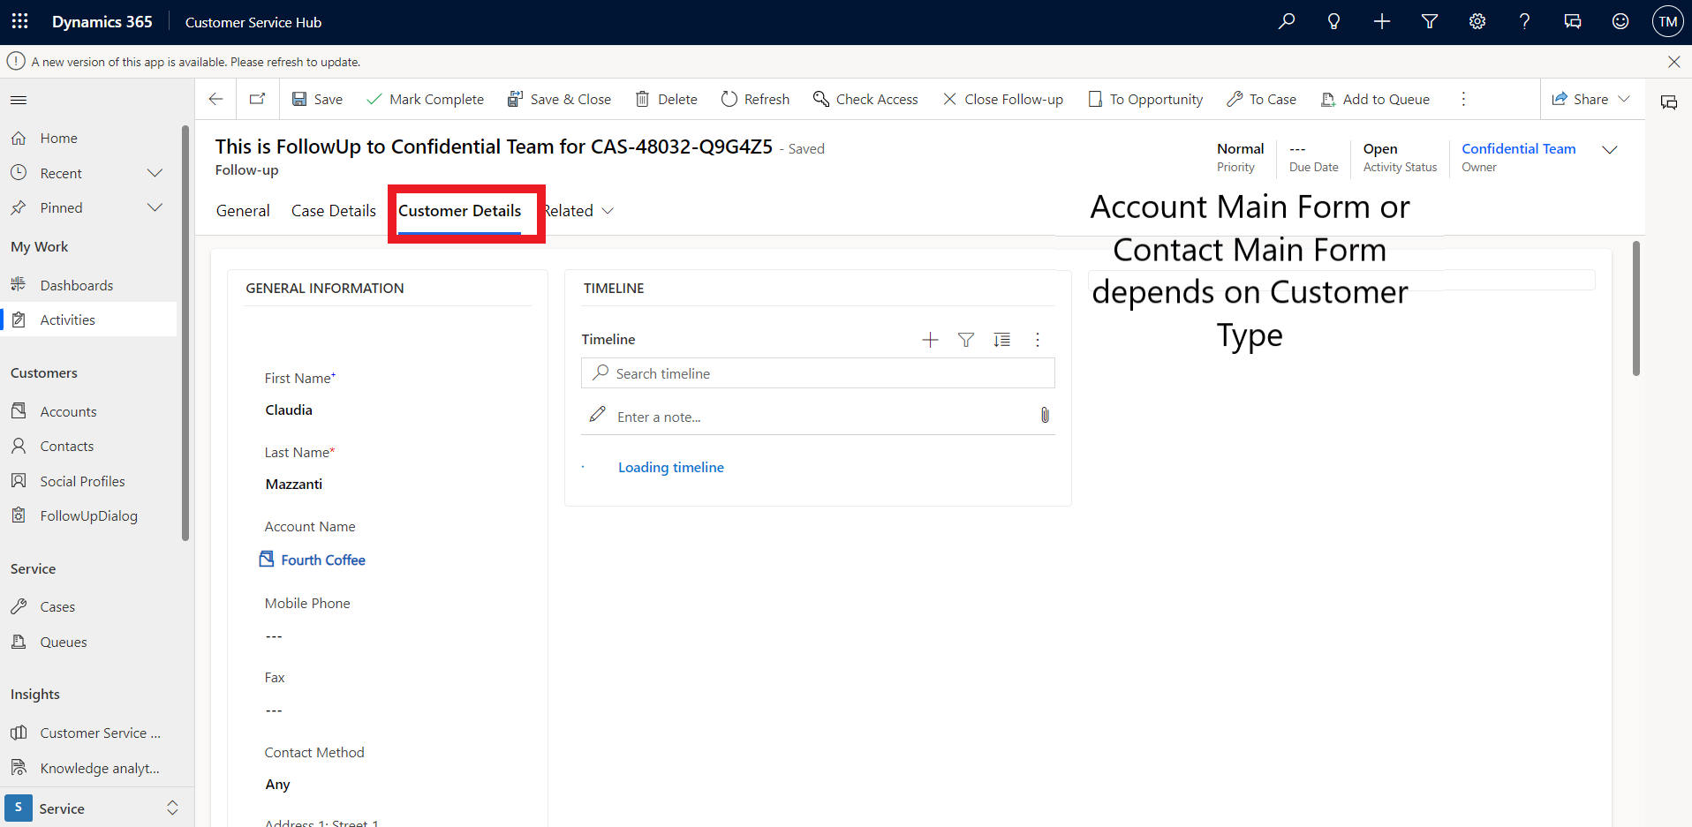

### Model Driven App

Using OOB App “Customer Service Hub” and Assign security roles (i.e., Customer service Agent and Customer Service Manager)

### Plug-in Customization (No Plugin, I have used power automate flow instead ‘Recommended from Microsoft’)

A plug-in is custom business logic (code) that can be integrated with Microsoft Dynamics 365 to modify or augment the standard behavior of the platform.

| Entity | Family | |
| --- | --- | --- |
| Message Type | |  |
| Execution Mode | |  |
| Description | |  |
| Filter attributes | |  |
| Execution Condition | |  |
| Action | |  |
| Execution Context | |  |
| Exclusion | |  |
| TFS ID | |  |

### Power Automate Flows

| Name | TFL Flow - Create Follow-Up on Case |
| --- | --- |
| Mode | Update of field |
| Description | When manager decide to follow up the case with confidential team in case incident is confidential or to escalation team in case manager can’t resolve case |
| Entity | Case |
| Action | When “follow up reason” field changes |

| Name | TFL Flow Send Email to Customer when Case Created |
| --- | --- |
| Mode | On Case Creation |
| Description | When agent create case for customer , customer will receive email notifying him that the case have been created with case number |
| Entity | Case |
| Action | Send Email to Customer |

| Name |  |
| --- | --- |
| Mode | When case resolved |
| Description | After case has been resolved within estimate time, customer will receive email that his case has been resolved on time. |
| Entity | Case |
| Action | Send Email to Customer |

### Business Process Flow

Using OOB Business Process Flow with some customizations

1. Identify Stage: Add ‘Is Confidential?’ field to classify the case
2. Research Stage: Add Comments field if agent need to add notes for manager
3. Resolve Stage: Add ‘Can Resolve Case?’ for manager to decide whether he/she can solve case or not
4. Closure Stage (New): if ‘Can Resolve Case?’ is yes closure stage will appear if not the case will still under investigation and closure stage won’t appear

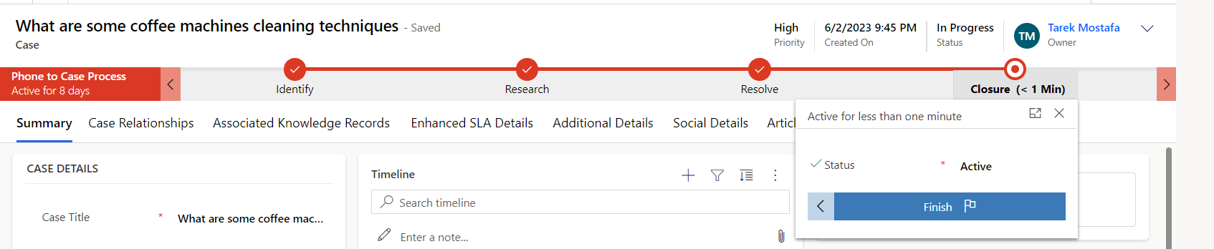

### Custom Page

I have created a custom page using PowerApps appears when Manager click on “Follow-up” button to create follow-up record for Confedential team or escalation team based on “Follow-up” Reason field that he will choose.

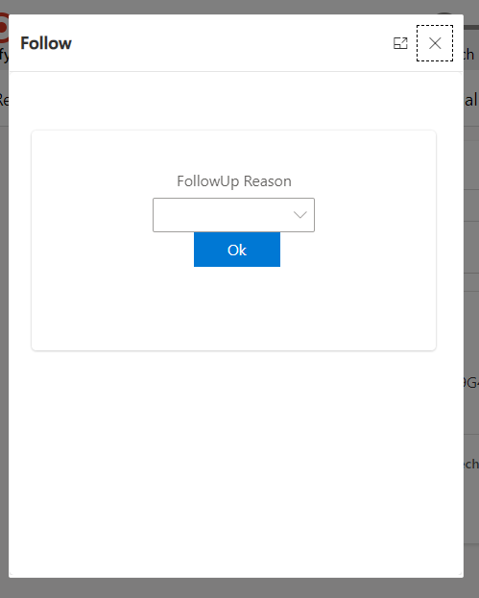

### Business Rules

Business rules allow for defining logic that takes place in a form. Business rules provide an alternative to form scripts because they can be defined within a user interface without writing code.

| Name | TFL BR- make can resolve? field mandatory on it's active stage | |
| --- | --- | --- |
| Condition | If active stage is “Resolve” |
| Action | Make “Can Resolve?” Field Mandatory |

### Web Resources

* I have build JS script for Case Entity included:
  + **CheckManagerLogged()** : Check if the logged in user is Admin/Manager then updating a field called is Manager? This allows my track who logged in and take decision on show/hide fields and buttons
  + **CallCustomPage():** Method to call Custom Page which decide the reason for Creating Follow-Up  
    .

### Advanced Customizations

AdvancedCustomizations includeribbon customizations, visibility rules, actions performed, site map changes, etc.

| Name | Ribbon: Make Custom Button Called “Follow-Up” |
| --- | --- |
| Label | Follow-Up |
| Visible Rule | Visible when loggen in user is Manager/Admin and ‘is Confedential’ field is **yes** or ‘Can Resolve’ field is **No** |
| Action | Show/Hide |

### Dashboards

We are using OOB Dashboards for Active cases, Resolved Cases to track the progress.  
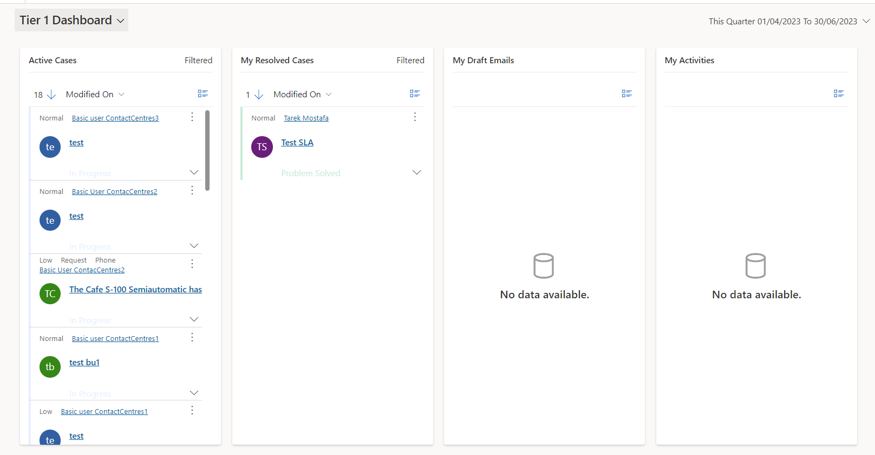

### Duplicate Detection Rule

I have made a duplicate detection rule on contact entity on ‘Email’ field, in case Agent tried to create a contact for case and he/she already exists detection rule will be applied

### Service Level Agreement (SLA)

I have Created SLA on ‘Priority’ Field to decide expected time to close the case based on priority options

SLA Item:

* High Priority: Expected time to expire is 2 hours and 1 hour to warning
  + Success condition: Status is Resolved
  + Configuration action: Create Power Automate flow to send email to customer when case is resolved successfully
* Normal Priority: Expected time to expire is 4 hours and 2 hours to warning
  + Success condition: Status is Resolved
  + Configuration action: Create Power Automate flow to send email to customer when case is resolved successfully
* Low Priority: Expected time to expire is 8 hours and 4 hours to warning
  + Success condition: Status is Resolved
  + Configuration action: Create Power Automate flow to send email to customer when case is resolved successfully











# 4 Security design

***Use these questions to guide this section to create a brief synopsis of a uniform security strategy.***

*What are the principal objectives to providing a secure environment?*

*What compromises in security are necessary for user convenience, usability and performance?*

*What specific security tools and technologies will be implemented within the solution?*

### 4.1.1 Business Units

|  |  |
| --- | --- |
| **Name** | **Duties** |
| Contact Centres1 | Responsible for Underground |
| Contact Centres2 | Responsible for Buses |
| Contact Centres3 | Responsible for Overground |

### Teams

|  |  |
| --- | --- |
| **Name** | **Duties** |
| Customer Service Agent Team | responsible to receive call and classify the case |
| Customer Service Manager Team | responsible to resolve cases or hand-off case for more information. |
| Confidential Team | Deal with confidential cases |
| Escalation Team | responsible to provide more information or possible resolution. |

**Note:** I have created these teams for each Business unit as per requirements each user can only work to their ContactCentres.

### 4.1.3 Security Roles

|  |  |
| --- | --- |
| **Name** | **Duties** |
| Customer Service Agent | responsible to receive call and classify the case |
| Customer Service Manager | responsible to resolve cases or hand-off case for more information. |
| Confidential | Deal with confidential cases |
| Escalation | responsible to provide more information or possible resolution. |

# Unit Test

### 

|  |  |  |  |  |
| --- | --- | --- | --- | --- |
| **Feature #** | **Description** | **Test Step** | **Input** | **Output** |
| 1 | Agent users receive call and create case | After agent receive call, he can   * Classify case * Find contact and create it if he/she does not exist * Assign Case to Manager |  |  |
| 2 | * Manager has cases assigned to him/her * Manager can take decision in that case | Manager can create a follow-up activity record with details of case and customer in case of   1. If case is Confidential 2. If can’t resolve case |  |  |
| 3 | Users in Escalation team can see follow-up record assigned to them by manager | After manager create a follow-up record because he can’t resolve case. it will be assigned to escalation team and they can take decision |  |  |
| 4 | Users in Confidential team can see follow-up record assigned to them by manager | After manager create a follow-up record because the case if confidential. it will be assigned to confidential team, and they can deal with it. |  |  |

### Test Cases

|  |  |  |  |
| --- | --- | --- | --- |
| **Numbers** | **Purpose** | **Steps** | **Cred** |
| Case 1 | Check user in Customer Service Agent team with Customer Service Agent Role can create case and classify it and assign it to managers without taking decisions | 1. Log in (Impersonate) with basic user in customer service agent team with BU ‘ContactCentres1’ 2. Create Case for customer and find contact if not already exists if exist duplicate detection rule will be applied and saying we have already contact with this email 3. Assign case to manager in same BU | **Display Name:** Basic user ContactCentres1 **Username:** [BUCC1@TFL455.onmicrosoft.com](mailto:BUCC1@TFL455.onmicrosoft.com)  **Password:** P@ssW0rddCC1 |
| Case 2 | Check user in Customer Service Manager team with Customer Service Manager Role can task decision for case whether create a follow-up record for confidential team if case is confidential **or** resolve case if he can if he can’t create a follow-up record for escalation team | 1. Log in (Impersonate) with manager user in customer service manager team with BU ‘ContactCentres1’ 2. Can create a follow-up record for confidential team if case is confidential 3. Can resolve the case, in case he can’t resolve button will be disappear | **Display Name:** Manager ContactCentres1 **Username:** MCC1@TFL455.onmicrosoft.com  **Password:** P@ssW0rdCC1 |
| Case 3 | If you try log in with basic user on other BU he won’t be able to see this record | 1. Log in with basic user on contactcentre2 on record owned by basic user on contactcentre1, he can’t see this record. | **Display Name:** Basic user ContactCentres1 **Username:** [BUCC1@TFL455.onmicrosoft.com](mailto:BUCC1@TFL455.onmicrosoft.com)  **Password:** P@ssW0rdCC1  **Display Name:** Basic User ContacCentres2 **Username:** BUCC3@TFL455.onmicrosoft.com  **Password:** P@ssW0rdCC2 |